**TASK 4 KUBERNET USING SHELL SCRIPT**

**Step 1: MiniKube**

Start the minikube using minikube start command

**Step 2: Folder Creation**

Create a folder named task

**Step 3: New Yaml File**

Create a new vim file named scripts.yaml 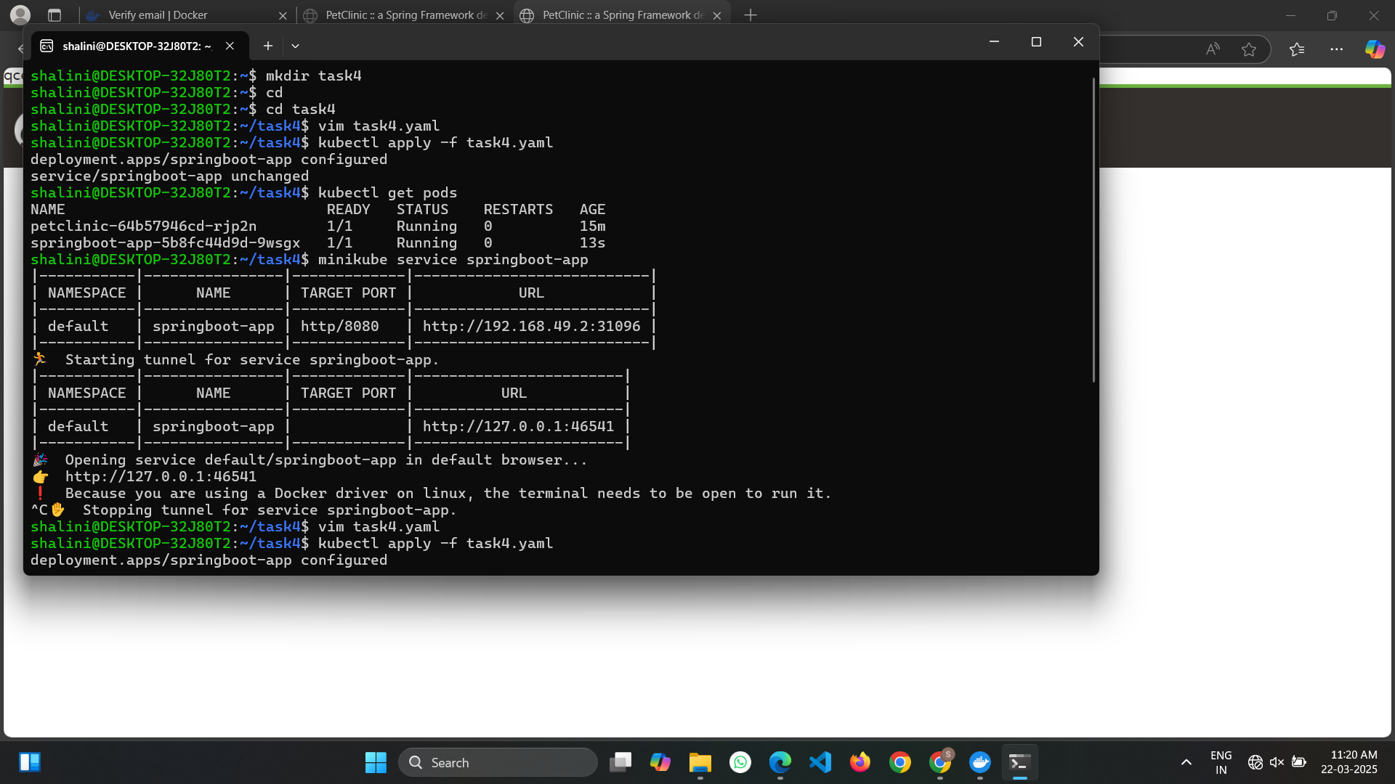

**Step 4: Yaml file**

Enter the yaml file code using the insert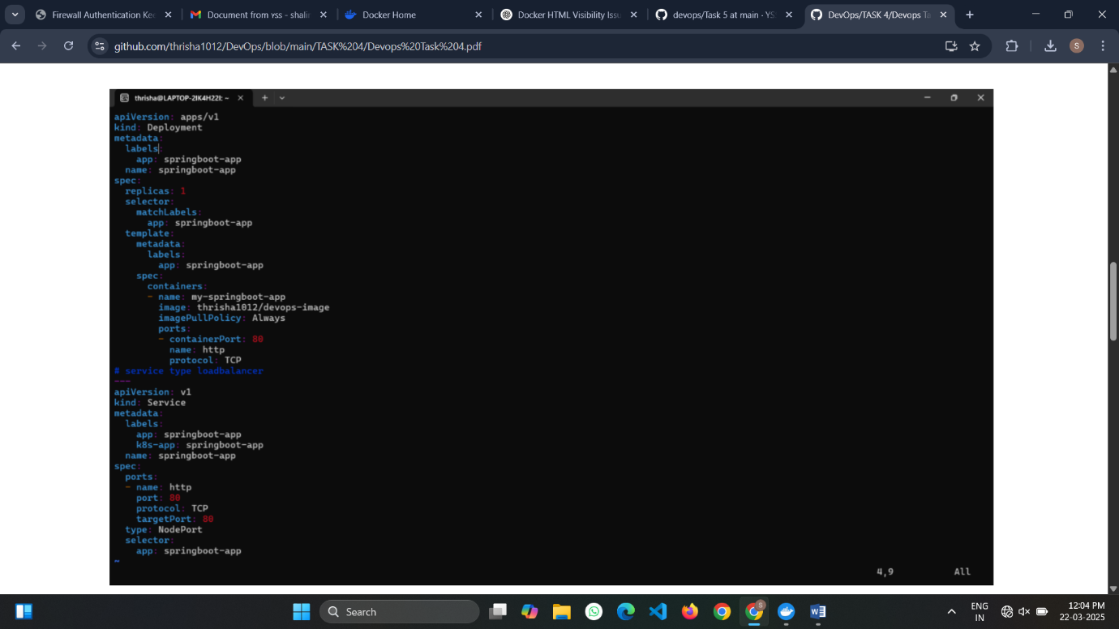

**Step 5: Apply**

Apply the changes made in the devops.yaml file

**Step 6: Get Pods**

Get the pods information to check if it is running or not.

**Step 7: Service**

Open the service springboot-app in the browser 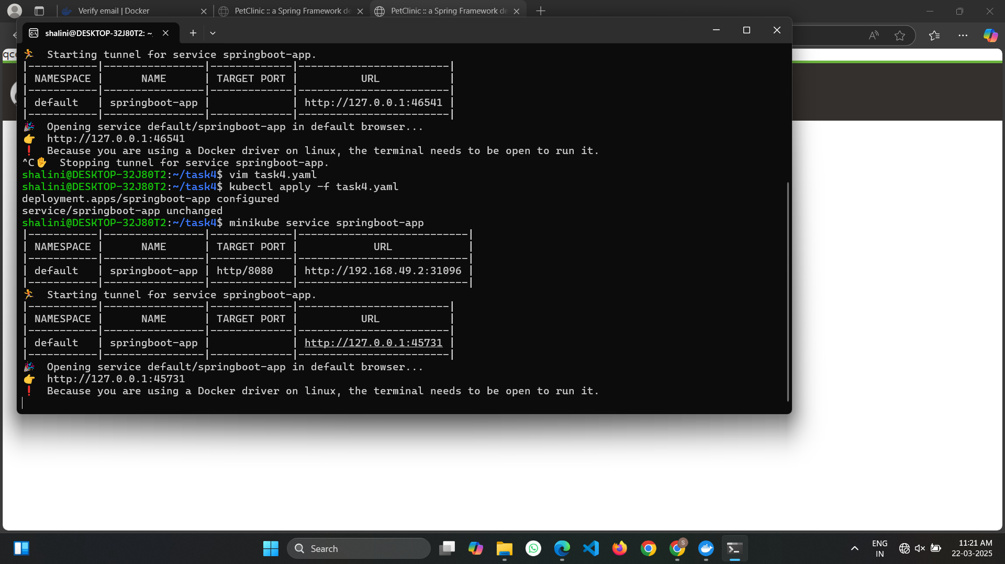

**Step 8: Output**

The output is shown in the browser in the localhost url present

